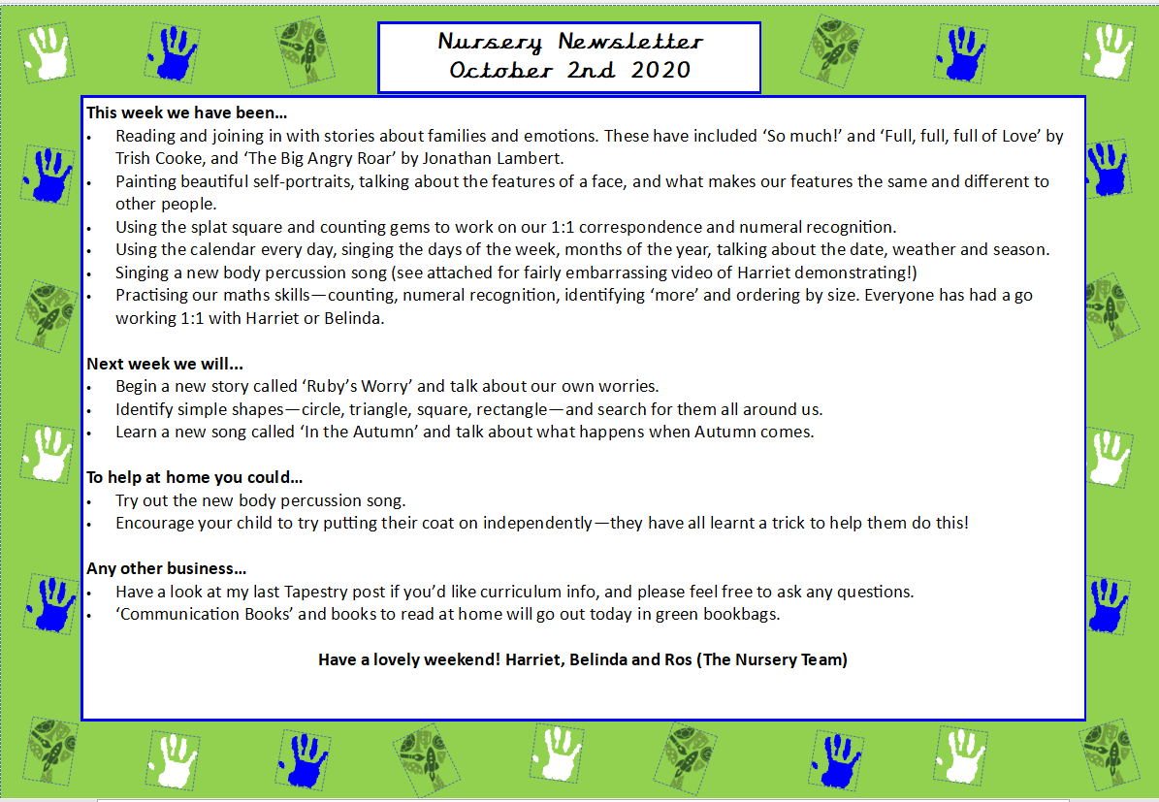
This week we:
- Read ‘Puffin Peter’ by Peter Horácek. We discussed different ways we can make ourselves feel better if we lose something special. We spoke about the lost property office, leaving special items at home, using kind words, helping our friends and letting an adult know.
- We discussed ways we can be a good friend during circle time, and how Peter was a good friend in the book.
- Learnt in Makaton the Nursery Rhyme- ‘Baa Baa Black Sheep’. The children were great with the actions and helped consolidate our learning on counting to three on our fingers.
- Played different games during carpet time to help the children order, count and recognise numbers 1-3.
- Listened to a variety of instruments in a sound box, where children had to identify the different noises and count the number of times they heard the sound.
- Played games to support communication and language such as ‘silly banana’
- At the craft table, we decorated mini puffins with feathers and glue and had a variety of different frozen objects in tuff trays for the children to investigate and try and excavate!

Next week we will:
- Read the story ‘Rainbow Fish’ which outlines the importance of sharing and including others.
- Make lots of rainbow fish and paint lots of fish at the craft table. The children will be encouraged to share out the sequins like the fish did in the story!
- In Maths, we will begin to learn to subitise to 3. This is where the children will be able to see a set of objects and be able to know how many there are without individually counting them. We will play lots of games with dice, and have opportunities for children to subitise amounts in tuff trays.
- Decorate pumpkins and investigate them using different excavation tools inn tuff trays.
- In PSHE, we will learn what ‘Being Responsible’ means. We will learn that that we are all responsible for looking after the classroom toys and praise lots of children with stickers throughout the week. For example, not throwing, stepping on or breaking toys, letting an adult know if something is broken or trying to fix things themselves.

Any other business:
- I can’t believe we are already nearly at the end of our first term! The children have come along so far already, and I look forward to speaking with you all at parents evening. The slots are from 3:30 in the nursery on Tuesday 20th October and from 1:30 on Tuesday 21st October in the hall.
- Please feel free to also post on tapestry if you and your child do anything exciting or they want to show something they are proud of.
Many thanks for all your ongoing support and we hope you have a lovely weekend!
Mr Fink and Belinda

Nursery Newsletter
16th October 2026

