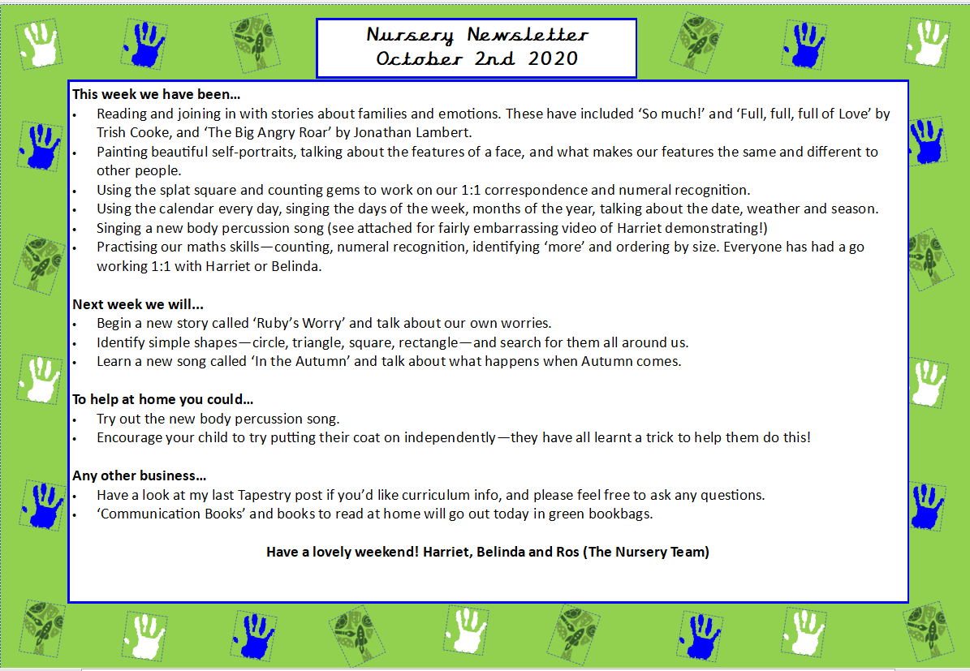
This week we:
- Read two new stories: ‘Ruby’s Worry’ and ‘The Colour Monster Goes to School’. We discussed big feelings and had lots of discussions on different types of emptions such as feeling ‘sad’, ‘angry’, ‘scared’, ‘happy’ and ‘excited’.
- We learnt to say ‘stop it- I don’t like it’ with hand actions when someone is doing something they don’t like to them, and to keep our hands to ourselves.
- We made scribble monsters like the one in ‘Ruby’s Worry’ to develop our fine motor skills.
- We painted our self-portraits which can be seen on the display in the classroom.
- We learnt about different things we can do to stop us feeling sad. For example, cuddling a favourite toy, listening to a story, going for a calm walk or spending some time in our calm down corner with some sensory toys.
- In Maths, we practiced counting on our fingers to three and recognising the written words for the numbers.
- Played sound bingo where the children cross off and identify the different environmental sounds they hear e.g. a kettle or a phone ringing.
Next week we will:
- Read a new text called ‘Puffin Peter’ by Peter Horácek. We will discuss different ways we can describe Peter e.g. soft, fluffy and discuss how we can make ourselves feel better if we lose something special.
- We will discuss ways we can be a good friend during circle time, and how Peter was a good friend in the book.
- Continue our work on numbers to 3 by counting on our fingers, singing songs and playing games to recognise the different numbers.
- We will sing Nursery rhymes that practice and emphasise counting to three in order such as ‘Baa Baa Black Sheep’ and ‘Wind the Bobbin Up’.
- Play ‘What’s in the Box’ during carpet time and encourage the children to identify the different environmental sounds they hear.
- In PSHE, we will learn that we should all be allowed to play, and that it is important to include others and use kind words.
- At the craft table, we will decorate mini puffins with feathers and glue and have a variety of different frozen objects in tuff trays for the children to investigate and try and excavate!
Any other business:
- Parents evening will take place from 3:30pm on Tuesday 20th October and from 1:30pm Wednesday 21st October
- Please keep all personal toys at home, as we have had a few incidents this week of things getting lost.
- Please return any reading books borrowed from school every Monday
- Please feel free to also post on Tapestry yourself if you want to share something you have done with your child at home. We love to discuss and share at carpet time different things the children have got up to or are proud of! It can be of anything from fun days out or something they have done which they are proud of like riding a bike or winning a competition.
Many thanks for all your ongoing support and have a lovely weekend!
Mr Fink and Belinda

Nursery Newsletter
9th October 2026

