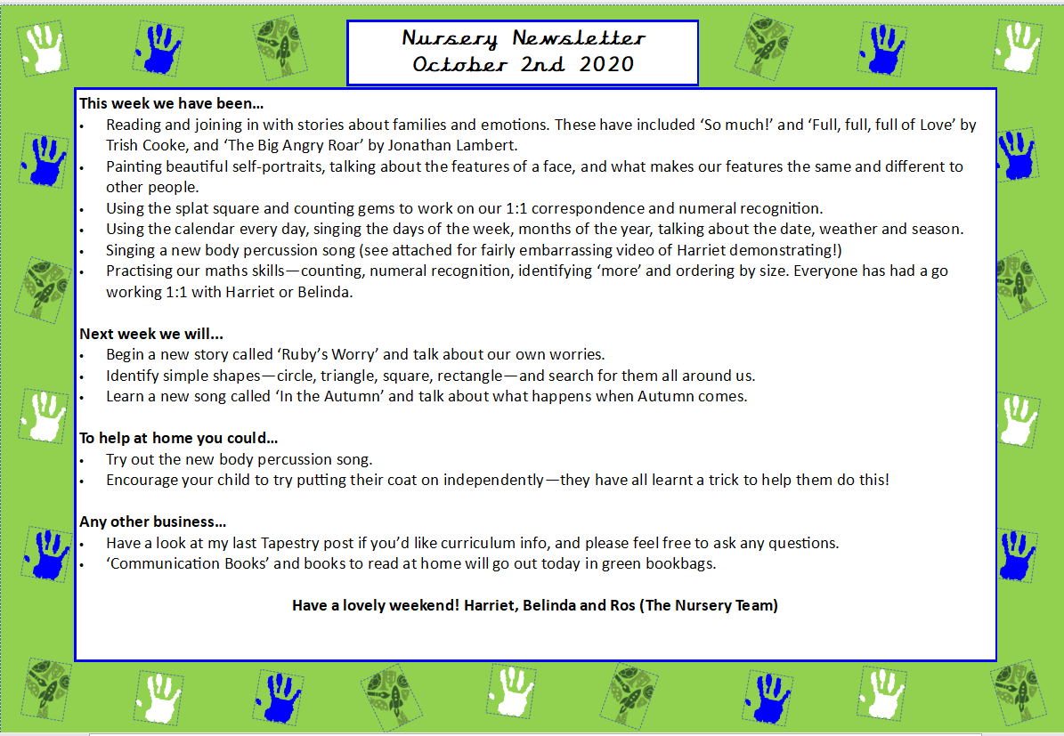
This week we:
- Read ‘Owl Babies’ by Martin Waddell and discussed different ways we can help ourselves if we are feeling sad. Some suggestions the children came up with were: hugging, choosing a favourite toy to cuddle and doing breathing exercises.
- We made very cute owl babies for our display in the KS1 corridor.
- Revised our knowledge on 2D shapes and created some shape monsters
- Practised songs to do with rhythm and rhyme using the parachute during circle time such as singing ‘Ring Around the Roses’ and ‘The Grand Old Duke of York’. The children identified the repeats in the songs and clapped/stomped along and followed the songs using a parachute
- Played ‘Guess the Sound’ where Mr Fink had a box of mysterious objects and the children had to guess the sound coming from the bag.
- Made simple ABAB patterns in the maths tuff tray using a variety of objects.
- Made playdough owls to support children’s creativity using natural recourses and develop their fine motor skills.

Next week we will:
- Read two new stories: ‘Ruby’s Worry’ and ‘The Colour Monster Goes to School’. These two books are excellent at discussing big feelings and we will have lots of discussions on different types of emptions such as feeling ‘sad’, ‘angry’, ‘scared’, ‘happy’ and ‘excited’. We will learn what colours are normally associated with these different emotions, how our faces look when feeling certain ways and discuss strategies to support self-regulation.
- We will paint our own self-portraits for our classroom display.
- We will talk about strong emotions such as sometimes feeling ‘sad’ or ‘angry’ when saying goodbye to our parents or caregivers in the morning. We will discuss these feelings and things we can do to stop us feeling sad. For example, cuddling a favourite toy, listening to a story, going for a calm walk or spending some time in our calm down corner with some sensory toys.
- In Maths, we will start learning number names to 5 where we will play carpet games to help with memory and learn certain songs to help support the children recognise the written words for numbers.
- Play sound bingo where the children cross off and identify the different environmental sounds they hear e.g. a kettle or a phone ringing.

Any other business:
- Please make sure your child is in by 9 am each day. If not, they will be marked late by the school office, as the register is taken at 9 am each day.
- We are a ‘no nuts’ school so please ensure your child does not come in with nuts in their snack or packed lunch box. We also have a nut allergy in class.
- Snacks that are bought in are to be fruit or vegetables only in a named snack box/bag.
- Thank you so much for the flour, oil and rice- we get through loads in Early Years!
- Our PE lessons are Wednesday and Friday, please can the children wear appropriate clothing and footwear on these days to avoid accidents and injuries.

We hope you have a great weekend and thank you so much again for all support
Mr Fink and Belinda

Nursery Newsletter
2nd October 2026

