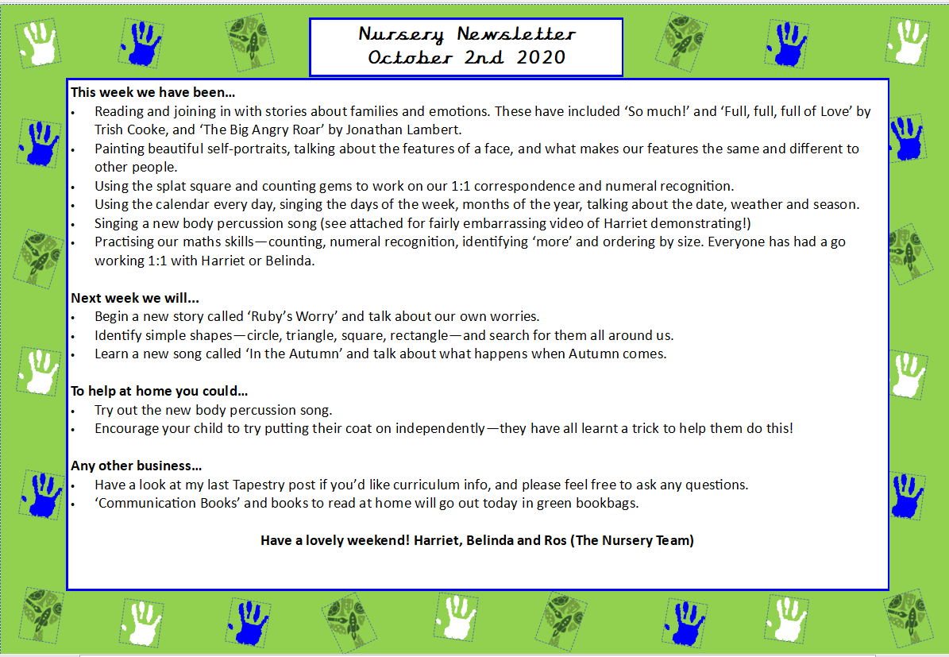
This week we:
- Sang our daily calendar songs including singing about the days, months and seasons of the year. We have also learnt a weather song and we take turns each day to check the weather for our calendar.
- Went on Autumnal walks outside, read stories about Autumn. We discussed what we see in Autumn and did lots of autumn craft including making leaf hedgehogs, leaf printing and making Autumnal trees using cotton-bud dabbers for our display.
- Began learning how to count to five on our fingers, and began our Maths topic on ‘More Than, Fewer Than and Same’. We played games on the carpet to consolidate our learning such as building cube towers, seeing which teacher can hold more of different items in the classroom and throwing different items in hoops in different teams to see who has ‘more’ or ‘less’.
- Continued practising our Nursery rule of ‘tidying as we go’ and got lots of stickers for helping tidy the classroom and learning where and how to store our toys.
- Practiced how we sit during carpet time following our super 5 sitting rules. We learnt actions that go with all our five rules which are: ‘eyes looking’, ‘ears listening’, ‘legs crossed’, ‘lips closed’ and ‘hand up to speak’. They have done really well with this so far!
- We started our Tapestry observations of what we have been doing this week and what conversations we have been having! Please contact the office if you are having any difficulties with Tapestry.
Next week we will:
- Read a new story called ‘Oh No George’. We will come up with suggestions as a class to help George make good choices and come up with our own Nursery Class Rules which we will refer to throughout the year. We will also make craft ‘George’s’ out of loo rolls. If you have any spare loo rolls at home, we would be so grateful if you could possibly bring some in to help with this craft idea.
- Begin learning about 2D shapes in Maths. We will look at basic properties such as how many sides and corners a triangle, square, circle and rectangle have. We will go on shape scavenger hunts, investigate what shapes we can see outside and learn songs about 2D shapes.
- Play games and sing songs with the parachute during carpet time to support communication and language as well as team building.
- Practice counting out objects to support 1:1 correspondence and sing Nursery rhymes to learn how to count to five on our fingers such as singing ‘1,2,3,4,5 Once I caught a Fish Alive’, ‘How Many Fingers on One Hand’ and ‘Five Little Speckled Frogs’.
- Take a book home from our reading corner to read with our parents! Please keep the book for the week and change the following week.
Any other business:
- PE days are Wednesday mornings with coach Ria and Friday mornings with coach Andre. Please can the children be wearing comfortable clothing those days and wear trainers.
- If snacks are bought in, please can they be fruit or vegetables only and in a labelled snack box.
- Nursery spare clothing donations would be much appreciated, as we are currently low on spare socks and leggings. Any spare kids clothing lying around the house- we’ll happily keep as spare in our Nursery changing rooms!
- We are making characters from the ‘Oh No George’ story and need toilet and kitchen rolls please.
Thank you all so much for your ongoing support. We hope you have a lovely weekend
Mr Fink and Belinda

Nursery Newsletter
18th September 2026

