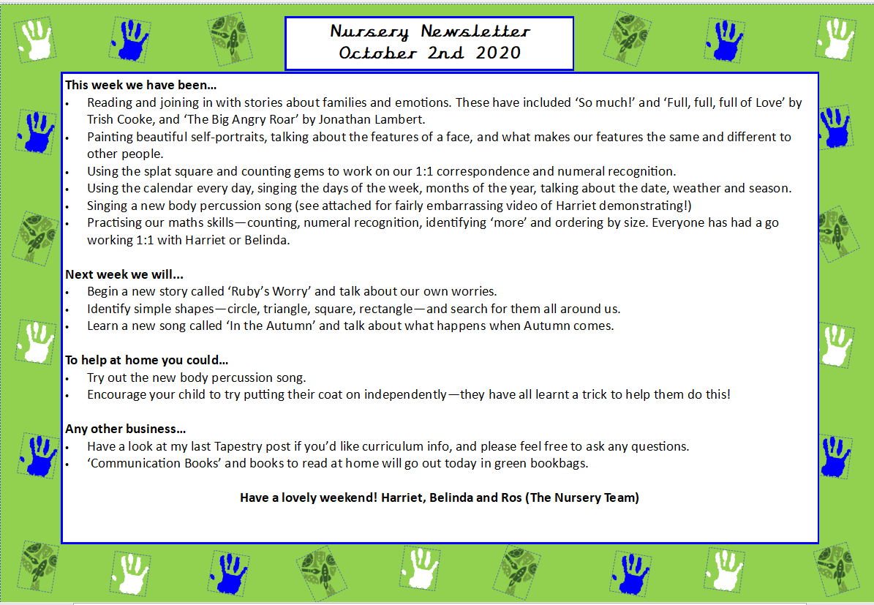
Hello everyone!
We have had a great first full week in Nursery! The children have settled in well, and it’s been such a joy getting to know them over these first few weeks. They’ve already shown so much enthusiasm and kindness, and we can’t wait to see all the exciting learning and discoveries they’ll be making very soon!
This week we:
- Familiarised ourselves with all the different things they can play with in the classroom. They also learnt where everything goes and how to keep their classroom safe and tidy.
- Got to know each other by playing ice-breaker games on the carpet such as ‘name games’ and ‘my favourite (colour, food, animal etc.) is…’
- Had our first PE sessions on Wednesday and Friday morning where the children played lots of games that involved moving in different ways and pretending to be different animals.
- Enjoyed playing lots outside and familiarising ourselves with where everything goes during tidy up time.
- Help to tidy our playground and learning about looking after our environment and each other.
- Leant to ‘freeze’ and use our listening ears when Mr Fink rings the shaker in the classroom.
- Practiced how we sit during carpet time following our super 5 sitting rules. We learnt actions that go with all our five rules which are: ‘eyes looking’, ‘ears listening’, ‘legs crossed’, ‘lips closed’ and ‘hand up to speak’. They have done really well with this so far!
Next week we will:
Carry on with understanding the Nursery rules, practice our good sitting, learn an Autumn song and consolidate singing our hello song and calendar songs. We will be completing lots of Autumn related activities such as leaf rubbings, going on nature walks, making playdough hedgehogs, counting autumnal objects in tuff trays and beginning our Maths topic called ‘More Than, Fewer Than, and Same’.
Any other business:
- Just a gentle reminder to not follow the children as they arrive (wherever possible) and to let them come into the classroom by themselves. It gets very crowded by the pegs and it can be quite overwhelming for the children.
- Please can all spare clothes, snack boxes and water bottles be labelled clearly. If children bring in a snack from home, it is fruit or vegetables only.
- Don’t forget to wear PE appropriate clothing and trainers on Wednesday and Friday mornings.
- Tapestry invites went out today, Friday 11th, please accept and sign up so you can start receiving weekly Tapestry updates of something that your child did each week.
- I have been made aware that a parent Whatsapp group has been set up with a QR code on the door our classroom to join.
- Pick up on Friday’s is at 2:30 (like the rest of the school) or 3:20. Please collect your child from the Nursery doors.
Have a lovely weekend- the children certainly need a good rest! Mr Fink and Belinda

Nursery Newsletter
11th September 2026

