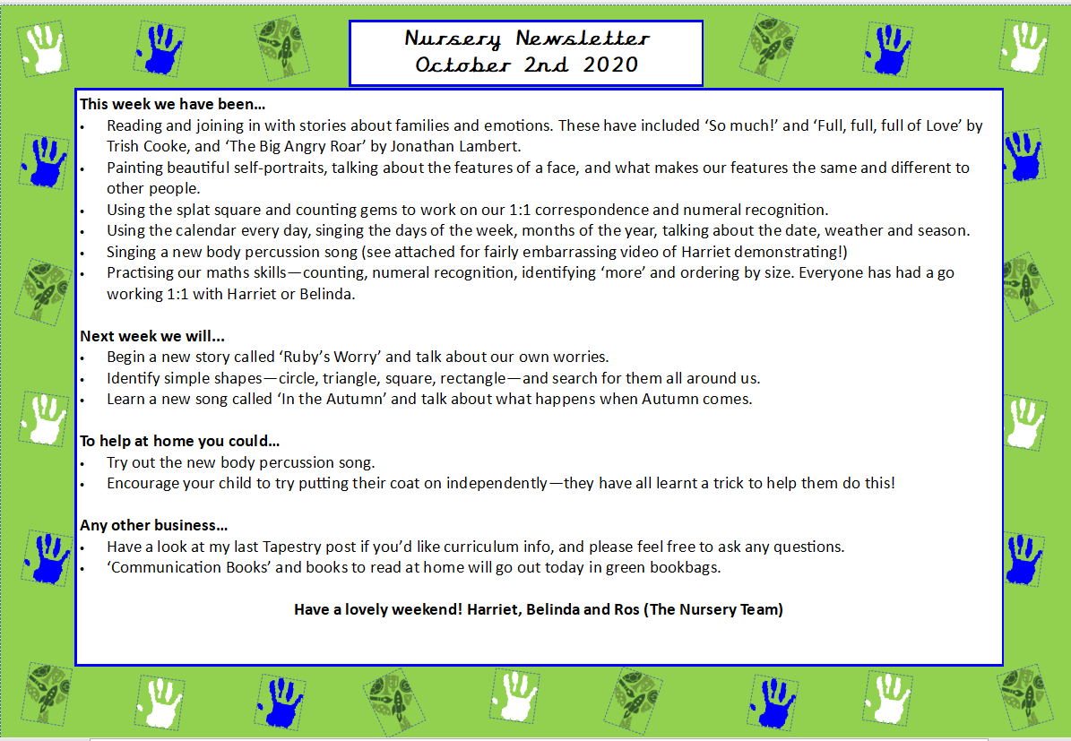
This week we:
- Read a new story called ‘Oh No George’. We came up with suggestions as a class to help George make good choices. This helped us come up with our own Nursery Class Charter. Some important rules we came up with were: ‘use kind words’, ‘use safe hands’ and ‘we include others’ and ‘use inside voices.’
- We made our own ‘Oh No George’ dog out of loo roll and paint.
- Began learning about 2D shapes in Maths. We learnt some new shape songs that involved making 2D shapes with our hands such as triangle, square, rectangle, heart and circle. The children also went on a shape scavenger hunt in the classroom to try and spot different shapes in their environment.
- Played ‘the shape game’ on the carpet where the children had to do an action each time they saw a certain shape whilst dancing to music. This was a great game to support their memory and listening skills.
- Practiced counting out objects to support 1:1 correspondence and sang Nursery rhymes to learn how to count to five on our fingers such as singing ‘1,2,3,4,5 Once I caught a Fish Alive’, ‘How Many Fingers on One Hand’ and ‘Five Little Speckled Frogs’.
Next week we will:
- Read a new story called ‘Owl Babies’ by Martin Waddell. We will talk about strong emotions such as sometimes feeling ‘sad’ or ‘angry’ when saying goodbye to our parents or caregivers in the morning. We will discuss these feelings and things we can do to stop us feeling sad. For example, cuddling a favourite toy, listening to a story, going for a calm walk or spending some time in our calm down corner with some sensory toys.
- We will make baby owls to go on our school display board in the KS1 corridor.
- In Maths, we will begin our topic called ‘Repeats’ where children will listen and identify repeats in songs or stories, clap along to songs using body percussion and recognise simple ABAB patterns.
- Play ‘Mr Fink has a Box’ where the children sing along to the tune of Old McDonald and guess what different objects are making sounds in the box.
Any other business:
- Thank you to those that donated any spare clothes! We are also running very low on oil, flour, and rice so if you have any of this spare at home too, we would be extremely grateful for any contributions.
- Please can you let the office know in advance if there are certain days your child does/does not have a packed lunch. The catering staff need to know exactly how many meals they need to prepare that morning for each child.
- A note for the diary- Nursery parents evening will take place on Wednesday 21st October. Further information about bookings and time slots will be emailed to you nearer the time.
- We really appreciate you adhering to the drop off at the door procedure. The children have become a lot more settled this week and it will really help them down the line when transitioning to Reception in future.
- The book the children took home on Wednesday, can that be returned on Monday so they can take a new book home!

We hope you have a lovely weekend and thank you again for your ongoing support
Mr Fink and Belinda

Nursery Newsletter
25th September 2026

