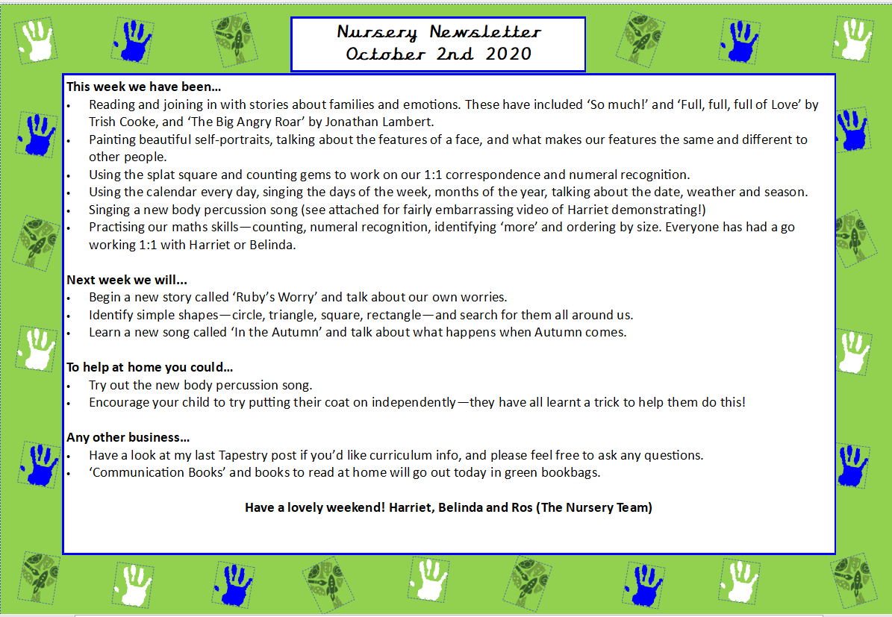
Nursery Newsletter
6th March 2026
Dear parents/carers,

This week we…

- This week we continued learning about our Farm Animals topic and had lots of fun exploring how animals help us.
- The children talked about what we get from animals, such as milk, eggs and wool, and how these products are useful in our daily lives.
- We enjoyed creating beautiful blossom trees to celebrate the arrival of Spring, using different materials and colours while developing our cutting and sticking skills.
- In phonics, the children played a farm animal guessing game. They listened carefully to clues and tried to work out which farm animal we were describing. This helped develop their listening skills and vocabulary.
- We also sang the nursery rhyme “5 Little Ducks”, joining in with the actions and practising counting as the ducks went out one day and came back again.
- The children had great fun sequencing the story Farmer Duck. The pictures were all mixed up and the children worked together to put the story back in the correct order, thinking about what happened first, next and last.
- We also celebrated World Book Day, which was a lovely opportunity for the children to talk about their favourite books and characters. It was wonderful to see their enthusiasm for stories and sharing books together.

Next week we will be…
Our farm topic will continue and our new focus story will be The Little Red Hen.
The children will be exploring the story by discussing:
- Who the characters are.
- How the characters might be feeling.
- What happens next in the story.
- Possible different endings.
We will also enjoy a variety of farm themed activities, including:
- Farm shop role play, where the children can pretend to buy and sell farm products.
- Talking about our favourite farm animals and explaining why we like them.
- Physical activities such as helping to “rescue the animals” and pretending to shear the sheep using different materials.
- Maths activities, including matching the correct number of animals to each field and practising subitising numbers 1–6.
- Exploring a Little Red Hen small world area and learning about the life cycle of a chicken.
- Making playdough bread and enjoying bakery role play in our creative area.
These activities will help develop the children’s language, early maths skills, creativity and understanding of the world.

Any other business

- Please ensure your child has two full sets of spare clothes in their bag at all times.

Thank you for your continued support.
Marina and Belinda

