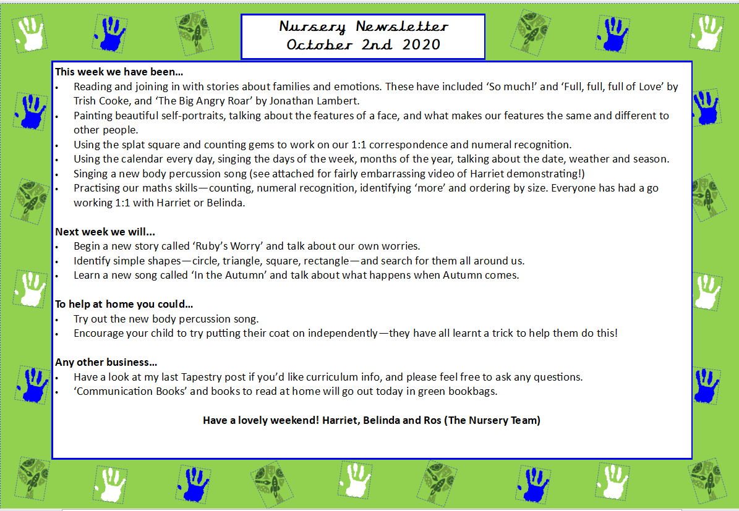
Nursery Newsletter
27th February 2026
Dear parents/carers,

This week we…

- Introduced our new topic all about Farm Animals.
- Explored what life is like on a farm and talked about where different animals live and why farms are important.
- Learned interesting facts about farm animals and discussed how they help people.
- Opened our Farm Shop role play area, taking turns to be customers and shop assistants to develop our communication and early maths skills.
- Created beautiful farm animal crafts, practising our cutting, sticking and fine motor skills.
- Helped Old McDonald to count his animals carefully and sang the nursery rhyme “Old McDonald Had a Farm.”
- Listened to our focus story Farmer Duck and discussed the main characters, their feelings and the key events in the story.

Next week we will be…

- Continuing to explore our Farm Animals topic in more depth.
- Learning new vocabulary linked to baby farm animals.
- Sequencing the story of Farmer Duck, ordering the main events and discussing what happens first, next and last.
- Thinking of alternative endings for the story and sharing our ideas with our friends.
- Exploring numbers 0–5 in different ways, challenging the children to represent each number using their fingers.
- Washing “mucky” farm animals in our water play area to develop our descriptive language and fine motor control.
- Sharing our favourite farm animal and explaining our reasons, building confidence in speaking and listening.

Reminders
World Book Day will take place on Thursday 5th March 2026. Children are welcome to come dressed as their favourite character if they wish and are encouraged to bring their favourite book to share.

Parents and carers are warmly invited to stay for free play from 8:40am to 9:15am to read stories together and enjoy some breakfast with the children.

Any other business

- Thank you to everyone who has already donated items for our Farm Shop role play area, we really appreciate your support. If you have any empty egg boxes, clean empty plastic milk bottles, empty food packaging or spare vegetables at home, you are still very welcome to bring them in.
- To help prevent the spread of head lice, we kindly ask that children with long hair come to nursery with their hair tied up (for example in a ponytail or plaits).
- Please ensure your child has two full sets of spare clothes in their bag at all times.

Thank you for your continued support.
Marina and Belinda

