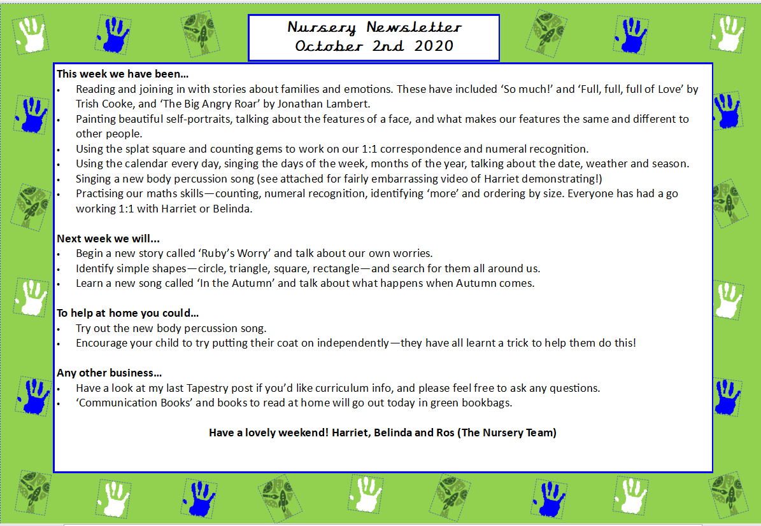
Nursery Newsletter
13th February 2026
Dear parents/carers,

This week we…

- Continued learning about Chinese New Year, exploring how and why it is celebrated.
- Listened to the story of The Great Race and talked about how the animals became part of the Chinese Zodiac.
- Took part in role play activities inspired by Chinese New Year, developing our communication and social skills.
- Created Chinese lantern and fan crafts, exploring colours, patterns and practising our cutting skills.
- Danced like dragons and lions, moving our bodies in different ways and following simple movement patterns.
- Practised our maths skills by exploring repeating patterns and counting carefully.
- Developed our fine motor skills through themed creative activities and mark-making inspired by Chinese symbols and numbers.

Next week we will be…

- Beginning our new topic all about Farm Animals, with a special focus on the story Farmer Duck by Martin Waddell.
- Exploring a farm sensory tray with cereal, hay and other textured materials, using toy animals for sorting and imaginative play.
- Creating farm animal crafts to develop our fine motor and creative skills.
- Opening our Farm Shop role play area, taking turns to be shopkeepers and customers to support communication and early maths skills.
- Playing in our farm small world area, retelling the story and creating our own farm adventures.
- Continuing to practise counting from 0–5 and exploring simple repeating patterns.
- Listening carefully to farm animal sounds in phonics and singing “Old McDonald Had a Farm.”

Half Term Suggestion

If possible during half term, we encourage families to visit a local farm. Seeing real farm animals helps children make meaningful links to our new topic and deepens their understanding through real-life experiences.

Any other business

- We are kindly asking for donations for our Farm Shop role play area. If you have any empty egg boxes, clean empty milk bottles, empty food packaging or spare vegetables, we would be very grateful.
- If your child brings grapes or cherry tomatoes for snack, please ensure they are cut in half lengthways to reduce the risk of choking. Thank you for your support with this.
- To help prevent the spread of head lice, we kindly ask that children with long hair come to nursery with their hair tied up (for example in a ponytail or plaits).
- Please ensure your child has two full sets of spare clothes in their bag at all times.

Thank you for your continued support. We hope you have a lovely half term!
Marina and Belinda

