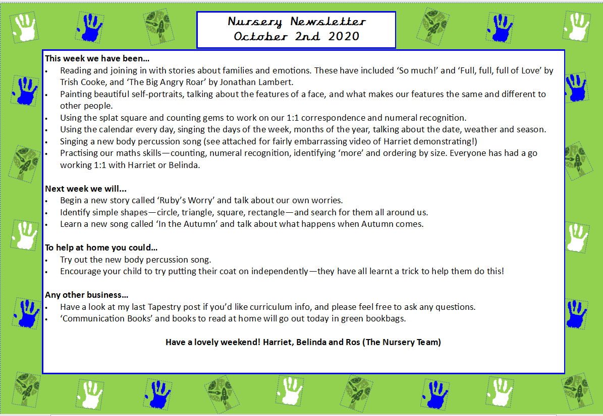
Nursery Newsletter
6th February 2026
Dear parents/carers,

This week we…
- Learned interesting facts about Chinese New Year, including how and why it is celebrated.
- Took part in role play, pretending to be waiters and customers in a Chinese restaurant, developing communication and social skills.
- Created Chinese lantern crafts and Chinese fan crafts, exploring colours, patterns, and creativity.
- Practised our maths skills by counting how many pompoms were on each lantern.
- Enjoyed listening to and learning the story of The Great Race, discovering how the animals became part of the Chinese Zodiac.
- Developed fine motor skills by cutting noodles and using scissors safely.

Next week we will be…
- Continuing our learning about Chinese New Year, exploring the celebration through stories, role play, music, movement, and creative activities.
- Playing a listening and attention game called “Penny Panda Is Lost in the Nursery”, focusing on recognising environmental sounds.
- Pretending to be the animals from The Great Race story and re-enacting the race through movement and role play.
- Practising pre-writing skills by copying Chinese numbers and some Chinese letters/symbols.
- Dancing like dragons and Chinese lions, following movement patterns.
- Exploring AB patterns by following dragon patterns as part of our maths learning.
- Celebrating Valentine’s Day on Friday 13th February. Children are invited to come dressed in pink, red, or wearing hearts.

Any other business
- Please upload a photo on Tapestry of the person or people your child loves by Wednesday 11th February, ready for our circle time discussion next Friday, 13th February.
- To help us prevent the spread of head lice, we kindly ask that children with long hair come to nursery with their hair tied up (for example in a ponytail or plaits). Thank you for your support with this.
- Please ensure your child has two full sets of spare clothes in their bag at all times (t-shirt, underwear, trousers, and socks).
- As you know, we regularly use flour, grains, pasta, and similar materials for sensory play and playdough. If you have any unopened or out-of-date items you no longer need, we would be grateful if you could donate them.

Thank you for your continued support. We hope you have a lovely weekend!
Marina and Belinda

