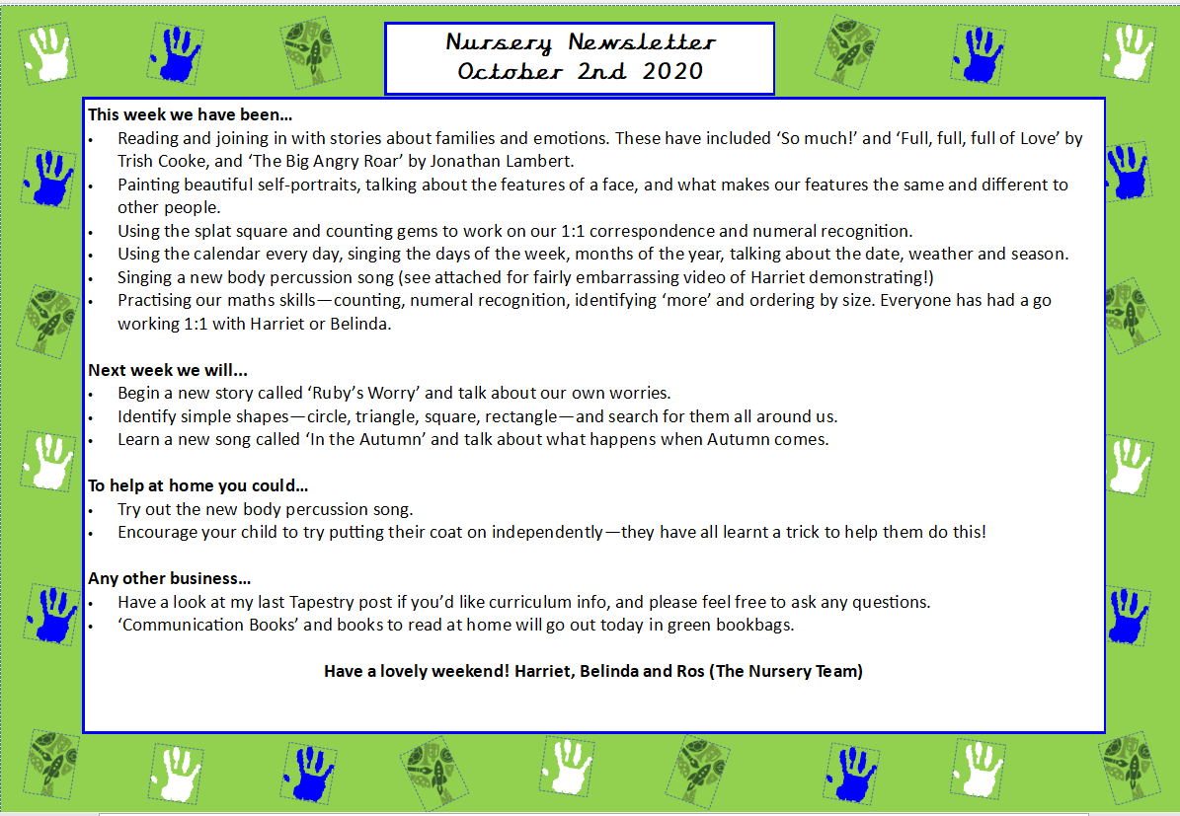
Welcome back to our second week of the term!
This week we…
- Have continued diving deeper into space and learning about aliens, going to space and shooting stars!
- Read the story of Aliens love Underpants and this led onto lovely conversation about life on other planets and what aliens might look like. We also had questions about aliens, for example, ‘Why do aliens love underpants?’ ‘What colour are aliens?’.
- Completed research to find out answers to our questions, we watched videos about shooting stars and how they are not actually stars at all but meteorites.
- Learnt more about the solar system and explored the colours and patterns that could be on the underpants that aliens love and had a go at painting them, as well as using arts and crafts such as googly eyes.
- Used 2-D shapes to create our own rockets and space vehicles.
- Dressed up as astronauts and role-played lots of adventures in space!
- Practiced subitising with animals and small world people.

Next week we will be…
- Leaving our space theme and moving onto the world of Dinosaurs.
- Learning all about the different types of dinosaurs – meat eaters and plant eaters.
- What sound did a T-Rex make?
- Practising subitising numbers to 5.
- Creating our own dinosaur worlds using playdough, toys and other materials.
- Painting and creating our own dinosaurs.
- Using 2D shapes to make rockets and use 3D shapes to create dinosaurs.
- Learning about where dinosaurs lived.

Any other business…
- As stated in the previous newsletter, any grains, flour and pasta would be much appreciated for playdough and the activities we use in our nursery.
- Please make sure in this colder weather, that you are sending your child in with a hat and gloves.
- Tapestry observations have started this week and will continue to be updated next week.

Thank you all for your ongoing support. Have a lovely weekend.

Ash and Belinda

Nursery Newsletter
16th January 2026

