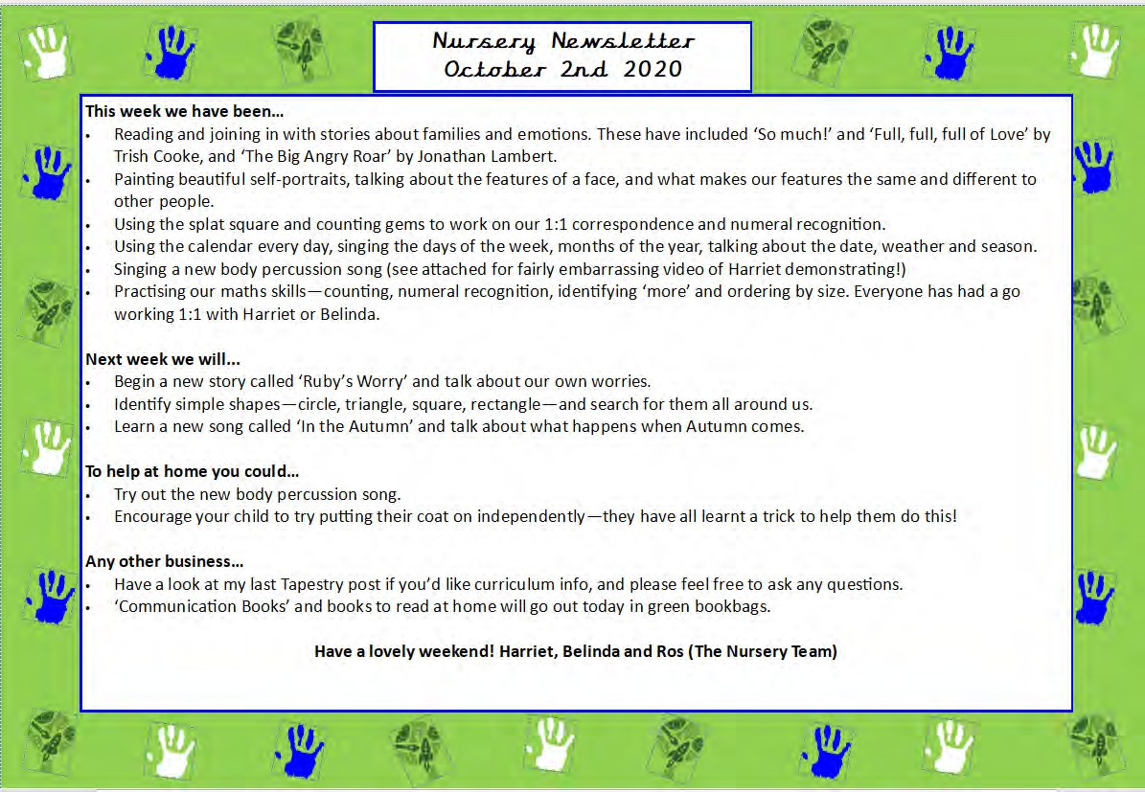
Nursery Newsletter 9th January 2026
Welcome back and Happy New Year! We hope you have had a restful and enjoyable break!

This week we…
- Have started this week off with our space theme!
- Read the story Astro Girl and this led onto lovely conversation about what we wanted to learn and questions we had about space, for example, ‘How do you eat in space?’ ‘How do you wash your hair in space?’.
- Completed research to find out answers to our questions, we watched videos of astronauts eating and washing their hair in space on their space stations!
- Learnt about the different planets and explored the colours and patterns we noticed on them and had a go at painting our own planets.
- Used the blocks to build rockets and retold space stories using the small world people.
- Dressed up as astronauts and role-played lots of adventures in space!
- Practiced counting out a number of objects.

Next week we will be…
- Continuing our theme on space, focusing on the story Aliens Love Underpants.
- Designing our very own underpants, using different skills, from drawing to collaging and painting.
- Writing list of what we would take to space and using our imagination to travel to space!
- Practising forming numbers to 5 and learning number rhymes to help us form them.
- Making alien headbands to turn ourselves into aliens!
- Designing our own aliens using playdough
- Using 2D shapes to make rockets and use 3D shapes to print rocket shapes.
- Designing and creating our own vehicles to take us to space using junk modelling.

Any other business…
- As you know, we use a lot of flour, grains, pasta etc. for sensory play and playdough making. If you have any grains, flour etc which you no longer need or is out of date, we would be grateful if you could bring this in for us to use. Thank you!
- Please make sure in this colder weather, that you are sending your child in with a hat and gloves.
- Tapestry observations will continue from next week.

Thank you all for your ongoing support. Have a lovely weekend.

Ash and Belinda

