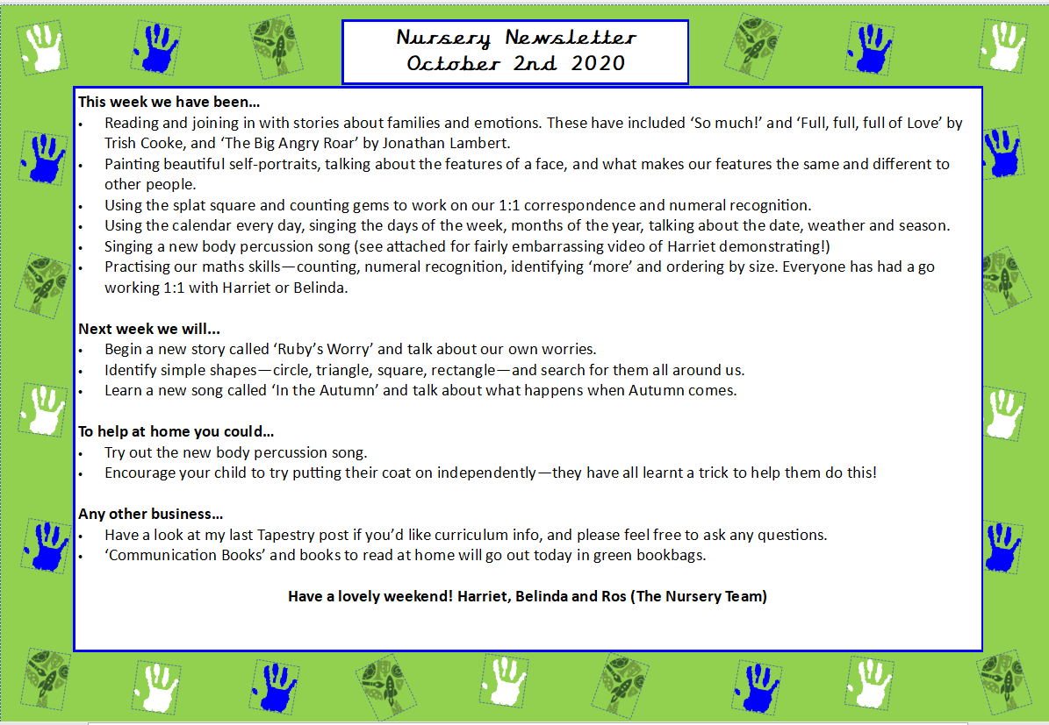
Hello everyone!
We have had a great first full week in Nursery! The children have settled in well, and it’s been such a joy getting to know them over these first few weeks. They’ve already shown so much enthusiasm and kindness, and we can’t wait to see all the exciting learning and discoveries they’ll be making very soon!
This week we:
- Familiarised ourselves with all the different things they can play with in the classroom. They also learnt where everything goes and how to keep their classroom safe and tidy.
- Got to know each other by playing ice-breaker games on the carpet such as ‘name games’, ‘pass the ball’, and ‘doggy, doggy, where’s your bone?’.
- Began learning the actions and the words for our ‘hello song’ and calendar songs.
- Had our first PE sessions on Wednesday and Friday morning where the children played lots of games that involved tagging, dancing and pretending to be different animals.
- Enjoyed playing lots outside and familiarising ourselves with where everything goes during tidy up time.
- Leant to ‘freeze’ and use our listening ears when Yasmiin rings the bell in the classroom.
- Practiced how we sit during carpet time following our super 5 sitting rules. We learnt actions that go with all our five rules which are: ‘eyes looking’, ‘ears listening’, ‘legs crossed’, ‘lips closed’ and ‘hand up to speak’. They have done really well with this so far!
Next week we will:
Carry on with understanding the Nursery rules, practice our good sitting, learn an Autumn song and consolidate singing our hello song and calendar songs. We will be completing lots of Autumn related activities such as leaf rubbings, going on nature walks, making playdough hedgehogs, counting autumnal objects in tuff trays and beginning our Maths topic called ‘More Than, Fewer Than, and Same’.
Any other business:
- Just a gentle reminder to not follow the children as they arrive (wherever possible) and to let them come into the classroom by themselves. It gets very crowded by the pegs and it can be quite overwhelming for the children.
- An email was sent out about potty training. We just want to remind you that all children should be fully potty trained before starting in our nursery as stated on our website and at the welcome morning. Belinda and I are always available to speak to if you would like some further advice.
- Please can all spare clothes, snack boxes and water bottles be labelled clearly. If children bring in a snack from home, it is fruit or vegetables only.
- Don’t forget to wear PE appropriate clothing and trainers on Wednesday and Friday mornings.
- I have been made aware that a parent Whatsapp group has been set up. If you would like to be added, please speak to either Anca or Candice.
- Pick up on Friday’s is at 2:30 (like the rest of the school) or 3:20. Please collect your child from the Nursery doors.
Have a lovely weekend- the children certainly need a good rest! Yasmin and Belinda

Nursery Newsletter
12th September 2025

